Introduction

Many zoos have adopted the practice of displaying species in free-flight, mixed species exhibits as it offers a number of advantages, such as being an effective use of space, allowing for greater flexibility of species display and management, and enhancing overall guest experience. From a welfare perspective, free-flight aviaries provide most species with ample room and opportunities for natural interactions – such as engaging in feeding and social behaviours. However, maintaining exhibits of such scale and complexity are filled with challenges that are dependent on factors such as, species dynamics, population size, size of aviary and the current husbandry practices.

With the husbandry practices and routines considered, a single feeding method or strategy is usually implemented for the entire aviary as it is the most operationally sustainable. This means that animals in captivity are often fed highly prepared diets (e.g. peeled fruit or vegetables in small chunks) which are usually presented to them in a simplistic manner (Swaisgood & Shepherdson, 2006) either on trays or on plates. These methods discourage expressing natural feeding behaviours such as acquisition, processing, and foraging (Young, 2007). Therefore, it is important to review potential methods that can further enhance current food presentation strategies and to optimise on creating a fully enriched environment for the animals.

For this proposed project, our aim is to conduct a series of comparisons to observe the feeding behaviours of animals towards different food presentations. This study will utilise the theory of contrafreeloading as the basis for methodology to see if it exists in the Fragile Forest Exhibit, which is a mixed species, free flight aviary that houses more than 90 birds from 21 different species and over 40 mammals from 7 different species. One of the main species that we will be focusing on will be the ring-tailed lemurs. As they are currently part of a diet management program, we would also like to investigate if contrafreeloading exists for them in a different setting and the potential for enriched feeders to be utilized as a management tool. This pilot study is an ongoing effort to build upon the concept of enhancing all aspects of a captive animal’s environment. It will serve as the baseline for incorporating feeding devices as part of the daily food presentation for captive animals.

Proposed methodology

*Study site and subjects*

The Fragile Forest Biodome is an enclosed walk-through exhibit which houses a collection of mixed-species that includes reptiles, primates, small mammals, avians and fishes. This exhibit was chosen for this study due to its environmental complexity, size and composition of species housed. As the collection is made up of more than class of animals which are ecologically disparate, we found it would yield useful data to investigate the feeding behaviours and interactions towards not just the devices but within other species as well.

Presently, the animals in the exhibit are fed twice a day (morning and afternoon). The diet provided is separated into two main types: arboreal and ground. The arboreal feeders are placed at 6 elevated huts and the ground food is provided at 4 main sites. Arboreal feeders are categorised into two types of diets: primate/parrot and softbill birds. There are three different types of diets provided for the ground feeders: duck, ground birds, mousedeer. The duck diet consists of leafy vegetables, pulse mix (barley, lentils, peas, green bean) and chicken breeder pellets. The ground bird food includes, a fruit salad consisting of four different fruits (banana, apple, pear, papaya), insectivore patee, pulse mix and Versale-Laga T16 pellets. Water is also provided *ad libitum* on the ground.

*Overview*

A series of experiments will be conducted to investigate the usage of enrichment devices as feeders in the aviary amongst different species at different feeding locations and the usage of said devices when implemented in a den shared by a group of ring-tailed lemurs. Based on the results from the contrafreeloading experiments, we would be able to explore four main factors: spatial and temporal feeding relationships; amount of interaction time based on the different devices; number and type of species interaction; preference of food presentation (device vs tray). Additionally, any specific interspecies behaviours related to accessing or interacting with the devices will also be recorded. Other environmental variables will also be recorded such as the weather condition and time of day (morning vs afternoon). For this study, interaction will be defined as a direct engagement with an object by an animal, the focus of the animal is on the object that may or may not result in direct manipulation.

An instantaneous scan sampling method with 20 second intervals will be used to record the number of species interacting with the devices. To keep with the existing feeding schedule and frequencies of the aviary, experiments will be carried out twice a day from 0900-1200hrs and 1330-1630hrs. The experiments will be carried out at the four main feeding locations in the biodome, dubbed as – Entrance, Emergency Exit, Service Door, and Exit. As for the experiments conducted back of house with the group of six male ring-tailed lemurs, we will also follow their existing managed routine, experiments will run twice daily on two days of a week. The experiment will run from 0900-1200hrs and 1330-1630hrs. To cover all locations in the aviary and to minimise the influence of the observer’s presence on the animal’s behaviours during the experiment, camera traps will be used to capture the data.

A sample of the proposed overall timing and schedule:

|  |  |  |  |  |  |
| --- | --- | --- | --- | --- | --- |
|  | **Mon** | **Tue** | **Wed** | **Thu** | **Fri** |
| **0800-0830** |  |  |  |  |  |
| **0830-0900** |  |  |  |  |  |
| **0900-0930** | Lemurs BOH | Lemurs BOH | BIODOME | BIODOME | BIODOME |
| **0930-1000** |
| **1000-1030** |
| **1030-1100** |
| **1100-1130** |
| **1130-1200** |
| **1200-1230** |  |  |  |  |  |
| **1230-1300** |  |  |  |  |  |
| **1300-1330** |  |  |  |  |  |
| **1330-1400** | Lemurs BOH | Lemurs BOH | BIODOME | BIODOME | BIODOME |
| **1400-1430** |
| **1430-1500** |
| **1500-1530** |
| **1530-1600** |
| **1600-1630** |
| **1630-1700** |  |  |  |  |  |

*Device design*

Feeding enrichments used in captivity are very diverse in design and generally aim to encourage one or more aspects of natural feeding behaviour. As the feed used in this study is obtained as a premix from the zoo kitchen, whole natural food items which encourage processing behaviour before consumption were not explored. Instead, all the enrichment devices explored attempted to encourage searching, probing, device manipulation and the retrieval of food from concealed areas. These increase feeding time, reducing the amount of time in which animals were inactive, thus reducing boredom and helping to prevent the possible development of undesirable behaviour (Honess & Marin, 2006).

A set of criteria adapted from Hare et al., 2003 were considered during the selection for enrichment devices:

1. Each device must be fairly different from each other (i.e., encourage different interactions and behaviour)
2. Fairly affordable
3. Easy to clean and maintain, and set-up.
4. Long-lasting (e.g., waterproof)
5. Able to hold food within without it falling out immediately
6. Majority of species able to interact with enrichment
7. Safe for animals, keepers and guests

Lemurs in general tended to be less curious and quick to learn as compared to other non-human primates. This in conjunction with their decreased hand dexterity, resulting in the quick exclusion of overly complex enrichment commonly used for other primates (Sauther et al., 1999). Enrichment devices used in past studies on lemurs were pooled, these included: stuffed balls, Kong toys, smears, wire boxes, bamboo feeders(Browning & Moro, 2006; Fernandez & Timberlake, 2019; Maloney et al., 2010). Prior research has also suggested that hanging devices were effective in increasing foraging and natural foraging postures in lemurs (Britt, 1998). The selection of enrichment devices in zoos are often made with heavy emphasis on keeper opinion and anecdotal reports of previous successes(Fernandez & Timberlake, 2019). Thus, this study combined both keeper experience and prior research to obtain 4 diverse devices that were thought to have elicit the best interaction and response from multiple species.

1. Puzzle box – wooden opaque box with holes large enough for lemur hands and arms but not their heads
2. Puzzle ball – plastic ball with irregularly shaped holes hung 15cm above ground with holes too small for lemurs to reach into
3. Pipe Feeder – Opaque PVC pipe with 2 holes and open ends hung 15cm above ground
4. Net basket – plastic meshed basket with 2x2cm holes hung 15cm above ground

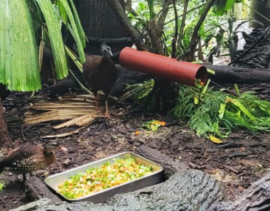 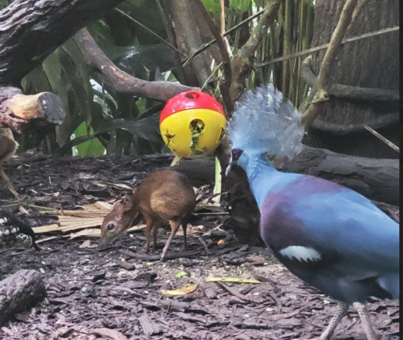 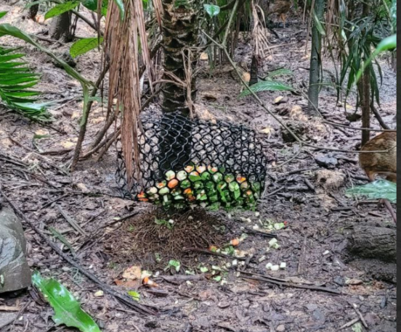

References

Britt, A. (1998). Encouraging Natural Feeding Behavior in Captive-Bred Black and White Ruffed Lemurs (Varecia variegata variegata). Zoo Biology, 17, 379–392. https://doi.org/10.1002/(SICI)1098-2361(1998)17:5

Browning, H., & Moro, L. (2006). A multi-sensory enrichment program for ring-tailed lemurs (Lemur catta) at Auckland Zoo, including a novel feeding device. Proceedings of the 1st Australasian Regional Environmental Enrichment Conference, 42–47. https://doi.org/10.13140/RG.2.2.10908.92809

Fernandez, E. J., & Timberlake, W. (2019). Selecting and Testing Environmental Enrichment in Lemurs. Frontiers in Psychology, 10, 2119. https://doi.org/10.3389/FPSYG.2019.02119

Hare, V. J., Ripsky, D., Battershill, R., Bacon, K., Hawk, K., & Swaisgood, R. R. (2003). Giant panda enrichment: Meeting everyone’ needs. Zoo Biology, 22(4), 401–416. https://doi.org/10.1002/ZOO.10109

Honess, P. E., & Marin, C. M. (2006). Enrichment and aggression in primates. Neuroscience & Biobehavioral Reviews, 30(3), 413–436. https://doi.org/10.1016/J.NEUBIOREV.2005.05.002

Maloney, M. A., Meiers, S. T., White, J., & Romano, M. A. (2010). Effects of Three Food Enrichment Items on the Behavior of Black Lemurs (Eulemur macaco macaco) and Ringtail Lemurs (Lemur catta) at the Henson Robinson Zoo, Springfield, Illinois. 9(2), 111–127. https://doi.org/10.1207/S15327604JAWS0902_2

Sauther, M. L., Sussman, R. W., & Gould, L. (1999). The Socioecology of the Ringtailed Lemur: Thirty-Five Years of Research. Evolutionary Anthropology, 8(4), 120–132. https://doi.org/10.1002/(SICI)1520-6505(1999)8:4

Swaisgood, R., & Shepherdson, D. (2006). Environmental enrichment as a strategy for mitigating stereotypies in zoo animals: a literature review and meta-analysis. Stereotypic animal behaviour: fundamentals and applications to welfare, 256–285. https://doi.org/10.1079/9780851990040.0256

Young, R. J. (2007). Environmental Enrichment for Captive Animals. Environmental Enrichment for Captive Animals, 1–228. https://doi.org/10.1002/9780470751046